Verification Specification / Report

Confidential! Only for use within Dräger Medical

Reference No. /Title / Revision
File location
Department

Summary of Test Results/Conclusion
Fail

Preparation / Test Equipment
Table 1: Devices involved in the verification process.
Equipment Type | Make and Model / HW Revision | ID/Serial Number | Software Version | Next Calibration

Introduction

Purpose/Test Description:
NOTE: Cells that are shaded are either for informational purposes or test steps that do not require a measurement result. For any test failures, provide detailed results. In all cases, it is expected to have an overall result (Pass or Fail) a pass indicates the ‘verify that…’ column was successfully accomplished. A fail indicates the ‘verify that…’ was not as expected.

This document is meant to demonstrate that Infinity Acute Care System VG8.0 complies with its specification(s) as listed below.

General

Change Log:

Rev | Date | Name | Description

Test Specification / Test Report
Test Case | Set Up / Procedure | Verify that... | Test Case Results | Pass/Fail
NA | For | NA | NA
 | Group Steps | 80,95,38  96  80 | Refer to Attachment #1  Refer to Attachment #2  Refer to Attachment #3 | Fail
 | Group Steps | 80,95,38  96  80 | Refer to Attachment #4  Refer to Attachment #5  Refer to Attachment #6 | Fail
 | Group Steps | 80,95,38  96  80 | Refer to Attachment #7  Refer to Attachment #8  Refer to Attachment #9 | Fail
 | Group Steps | 80,95,38  96  80 | Refer to Attachment #10  Refer to Attachment #11  Refer to Attachment #12 | Fail

Attachment #1

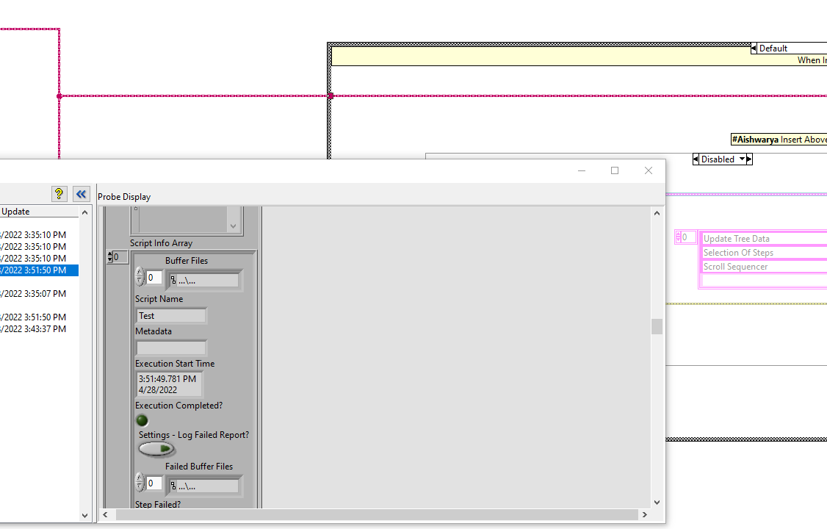

Attachment #2

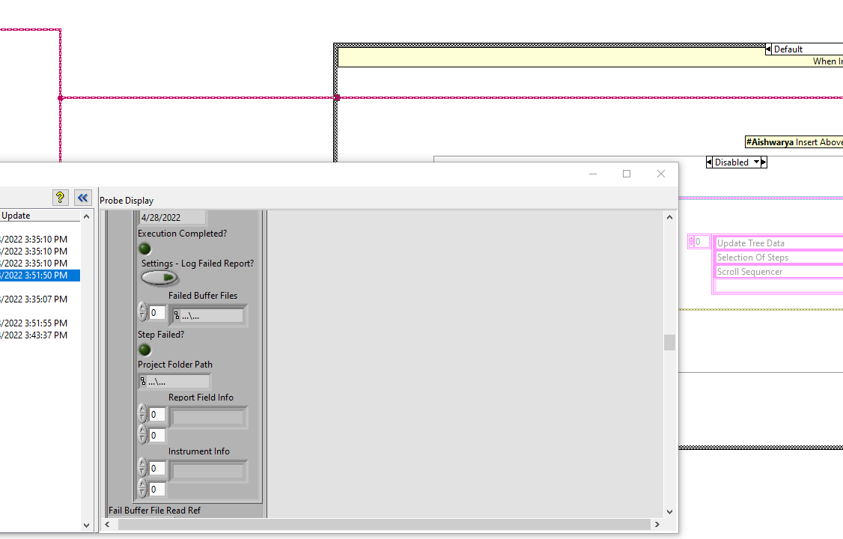

Attachment #3

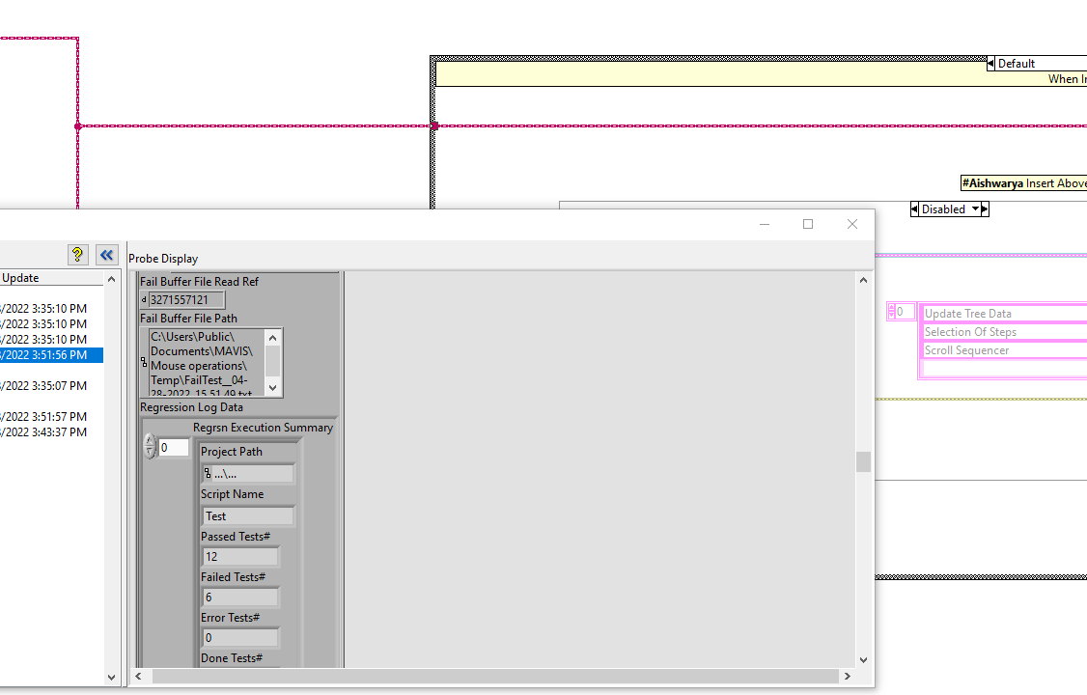

Attachment #4

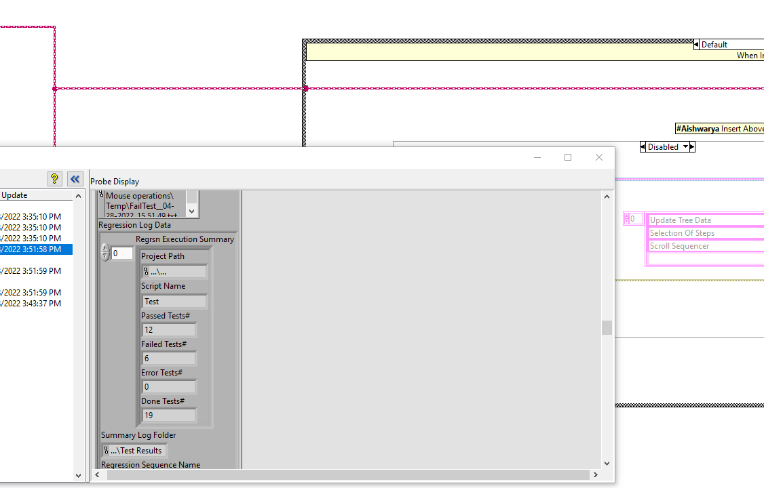

Attachment #5

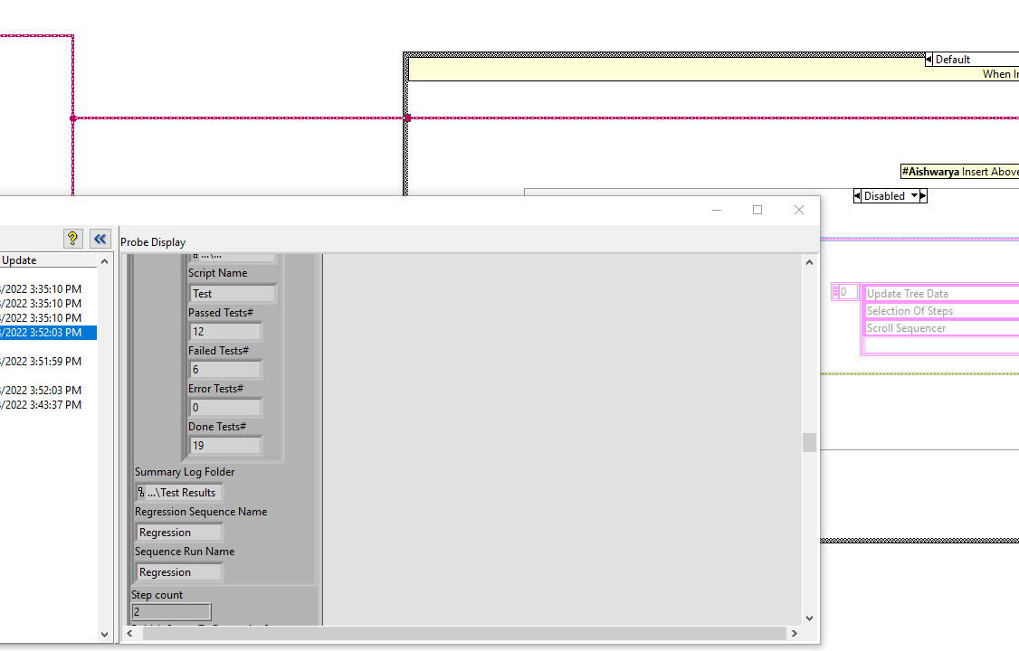

Attachment #6

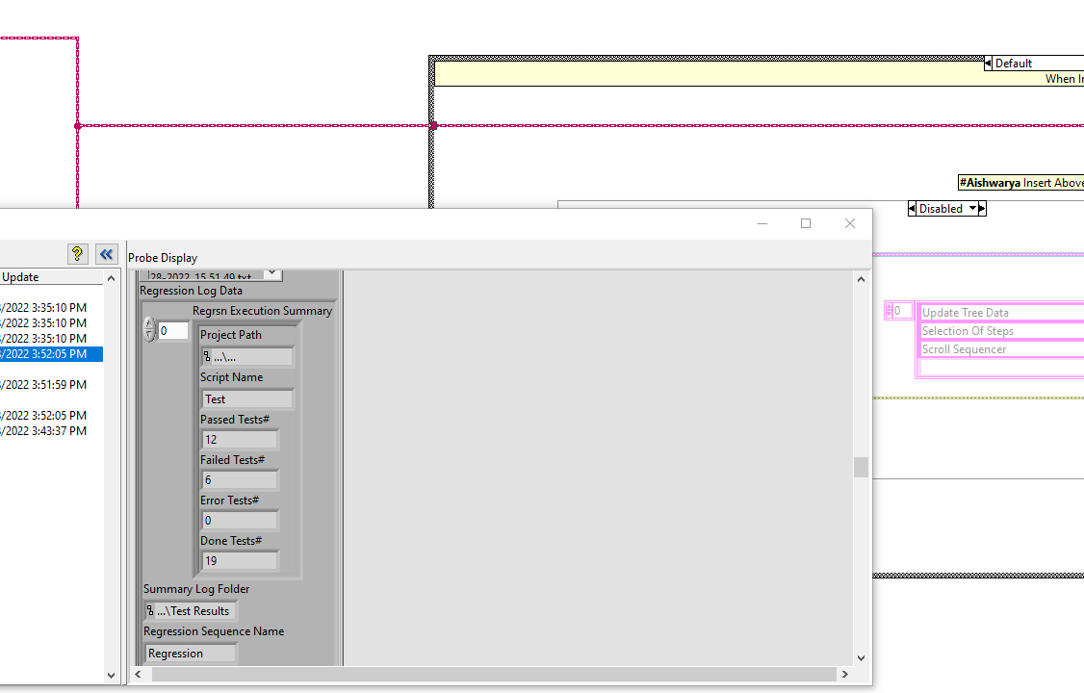

Attachment #7

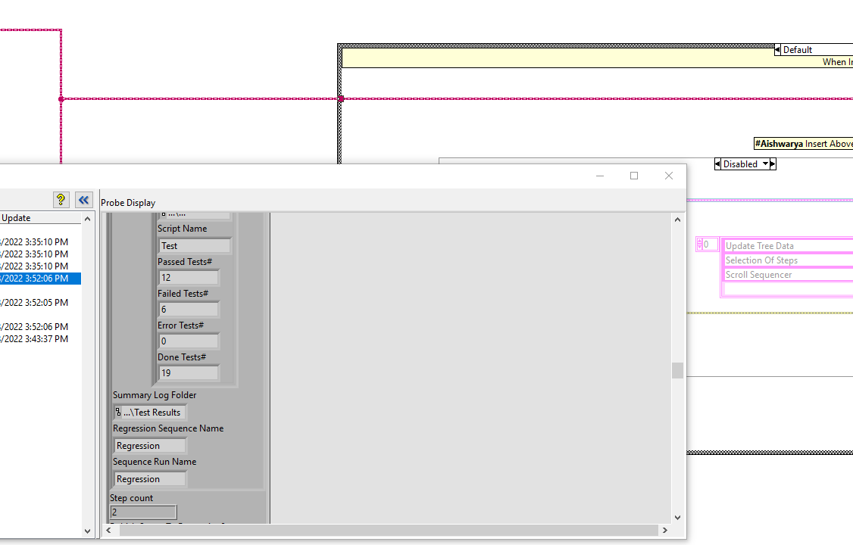

Attachment #8

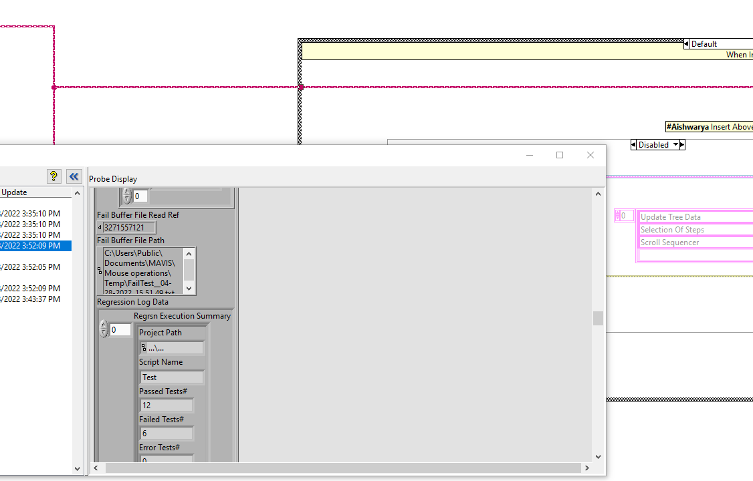

Attachment #9

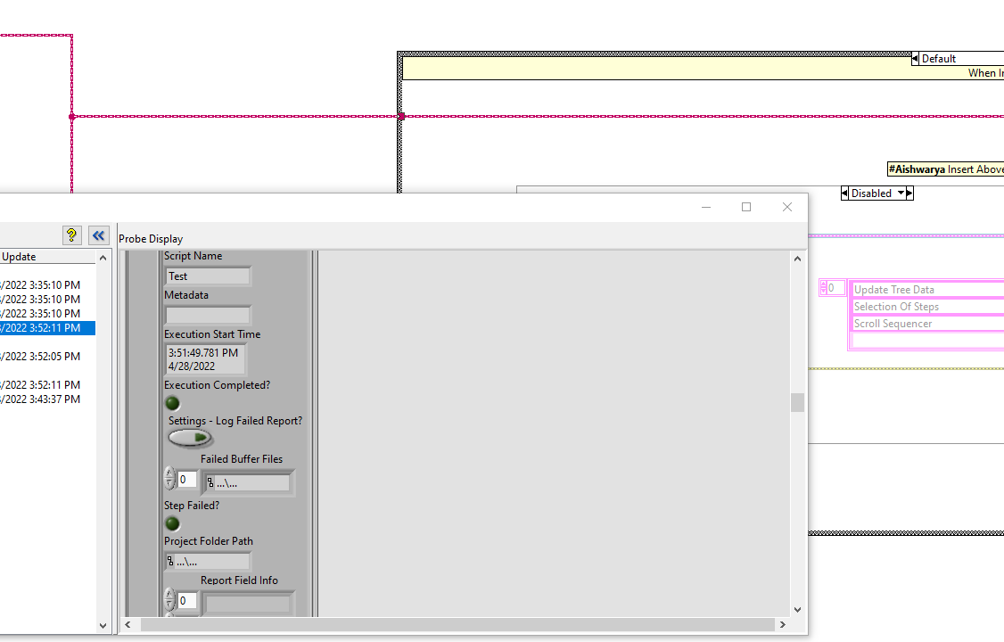

Attachment #10

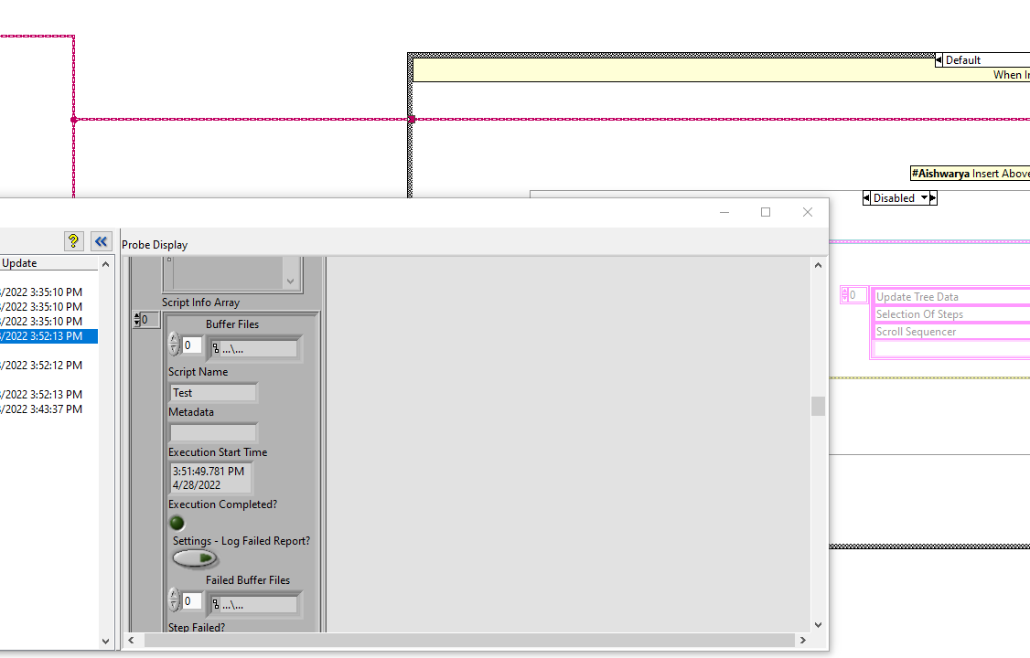

Attachment #11

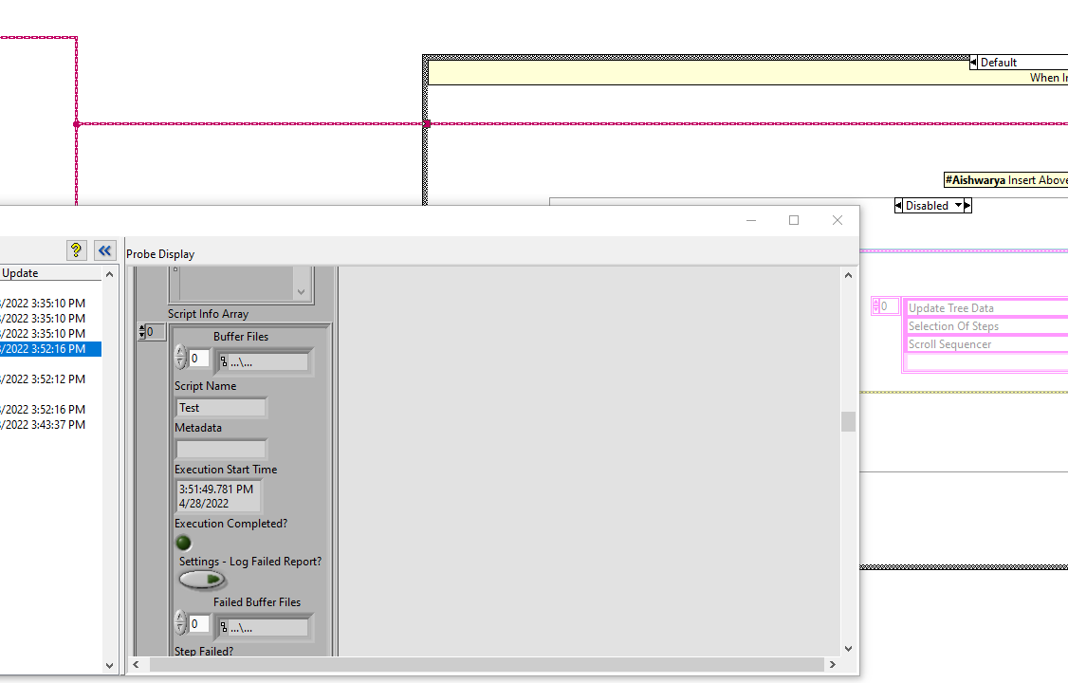

Attachment #12

